
MyBokSmart (https://my.boksmart.com) www.BokSmart.com /BokSmart  @BokSmart

Serious Injury Report Form
A serious and/or catastrophic injury is defined as any head, neck, spine, or brain injury that is life-threatening, or has the potential to be permanently debilitating and results in the emergency admission of a rugby player to a hospital or medical care centre.

WHAT TO DO!
- Record the details as accurately as possible regarding the player, the injury, and the relevant contact person from the school, club, or team in the spaces below
- Within 48 hours of the injury, Email the completed report to the Serious Injury Case Manager (SICM), Mrs. Shoneé Cornelissen – Cell: 0716831021, e-mail: manager@playersfund.org.za.
- The Serious Injury Case Manager will then inform SARU’s Senior Manager: Medical, SARU’s Senior Manager: Rugby Safety, and the relevant Provincial union.
RESEARCH
All serious injury data collected will be recorded and stored on a SARU database. Personal details will be provided to the Chris Burger/Petro Jackson Players Fund, who may provide financial assistance and support to catastrophically injured rugby players. This information will be stored at SARU’s offices for official records of these injuries. The injury data may be used for research and publication purposes to help improve the safety standards of the game of rugby in South Africa, and to potentially prevent other injuries of this nature from occurring in the future. However, in this instance, all personal information will be regarded as confidential in any ensuing research analyses and reports on the catastrophically injured players.
- By ticking this box, the player / parent / guardian / family member agrees to the above
World rugby (wr) (FORMERLY KNOWN AS ‘INTERNATIONAL RUGBY BOARD’ OR ‘IRB’)
All data collected will be forwarded anonymously to WORLD RUGBY and stored in a secure WORLD RUGBY database of catastrophic injuries. These data may be analysed by WORLD RUGBY for audit, player welfare, research purposes in relation to the prevention, and management of Rugby-related catastrophic injuries.
- By ticking this box, the player / parent / guardian / family member agrees to the above
PLAYER’s CONSENT
I give my express, informed consent for SARU to collect and use the information requested in this form and agree that the information can be forwarded to WORLD RUGBY, and be used by both SARU and WORLD RUGBY for the purposes of monitoring and investigating the causes of catastrophic injuries sustained in Rugby Union, in accordance with the SARU Privacy Policy.
- By ticking this box, the player consents to the above
PARENT/GUARDIAN/family member CONSENT
I give my express, informed consent for SARU to collect and use and submit the information requested in this form and agree that the information can be forwarded to WORLD RUGBY, and be used by both SARU and WORLD RUGBY for the purposes of monitoring and investigating the causes of catastrophic injuries sustained in Rugby Union, in accordance with the SARU Privacy Policy.
- By ticking this box, the parent / guardian / family member consents to the above
Parent/Guardian/Family member Name:
Parent/Guardian/Family member ID:

Parent/Guardian/Family member Signature:
1. PLAYER (Print Clearly)
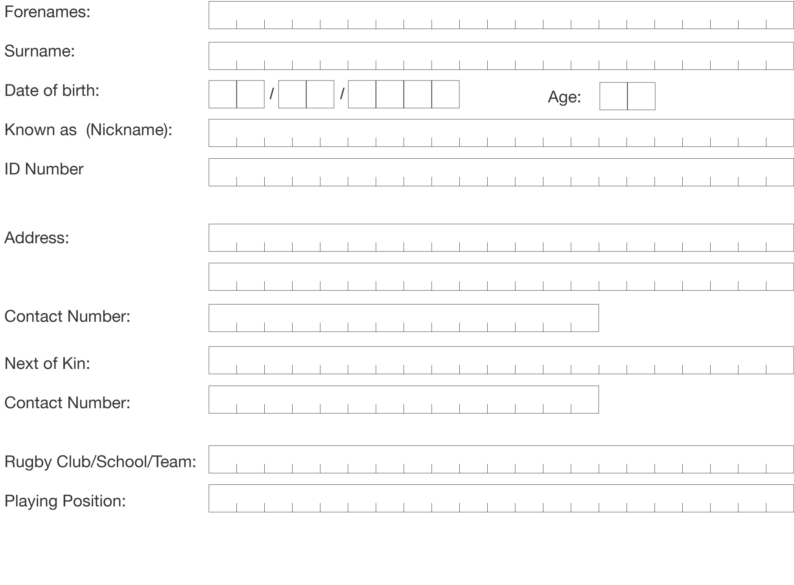

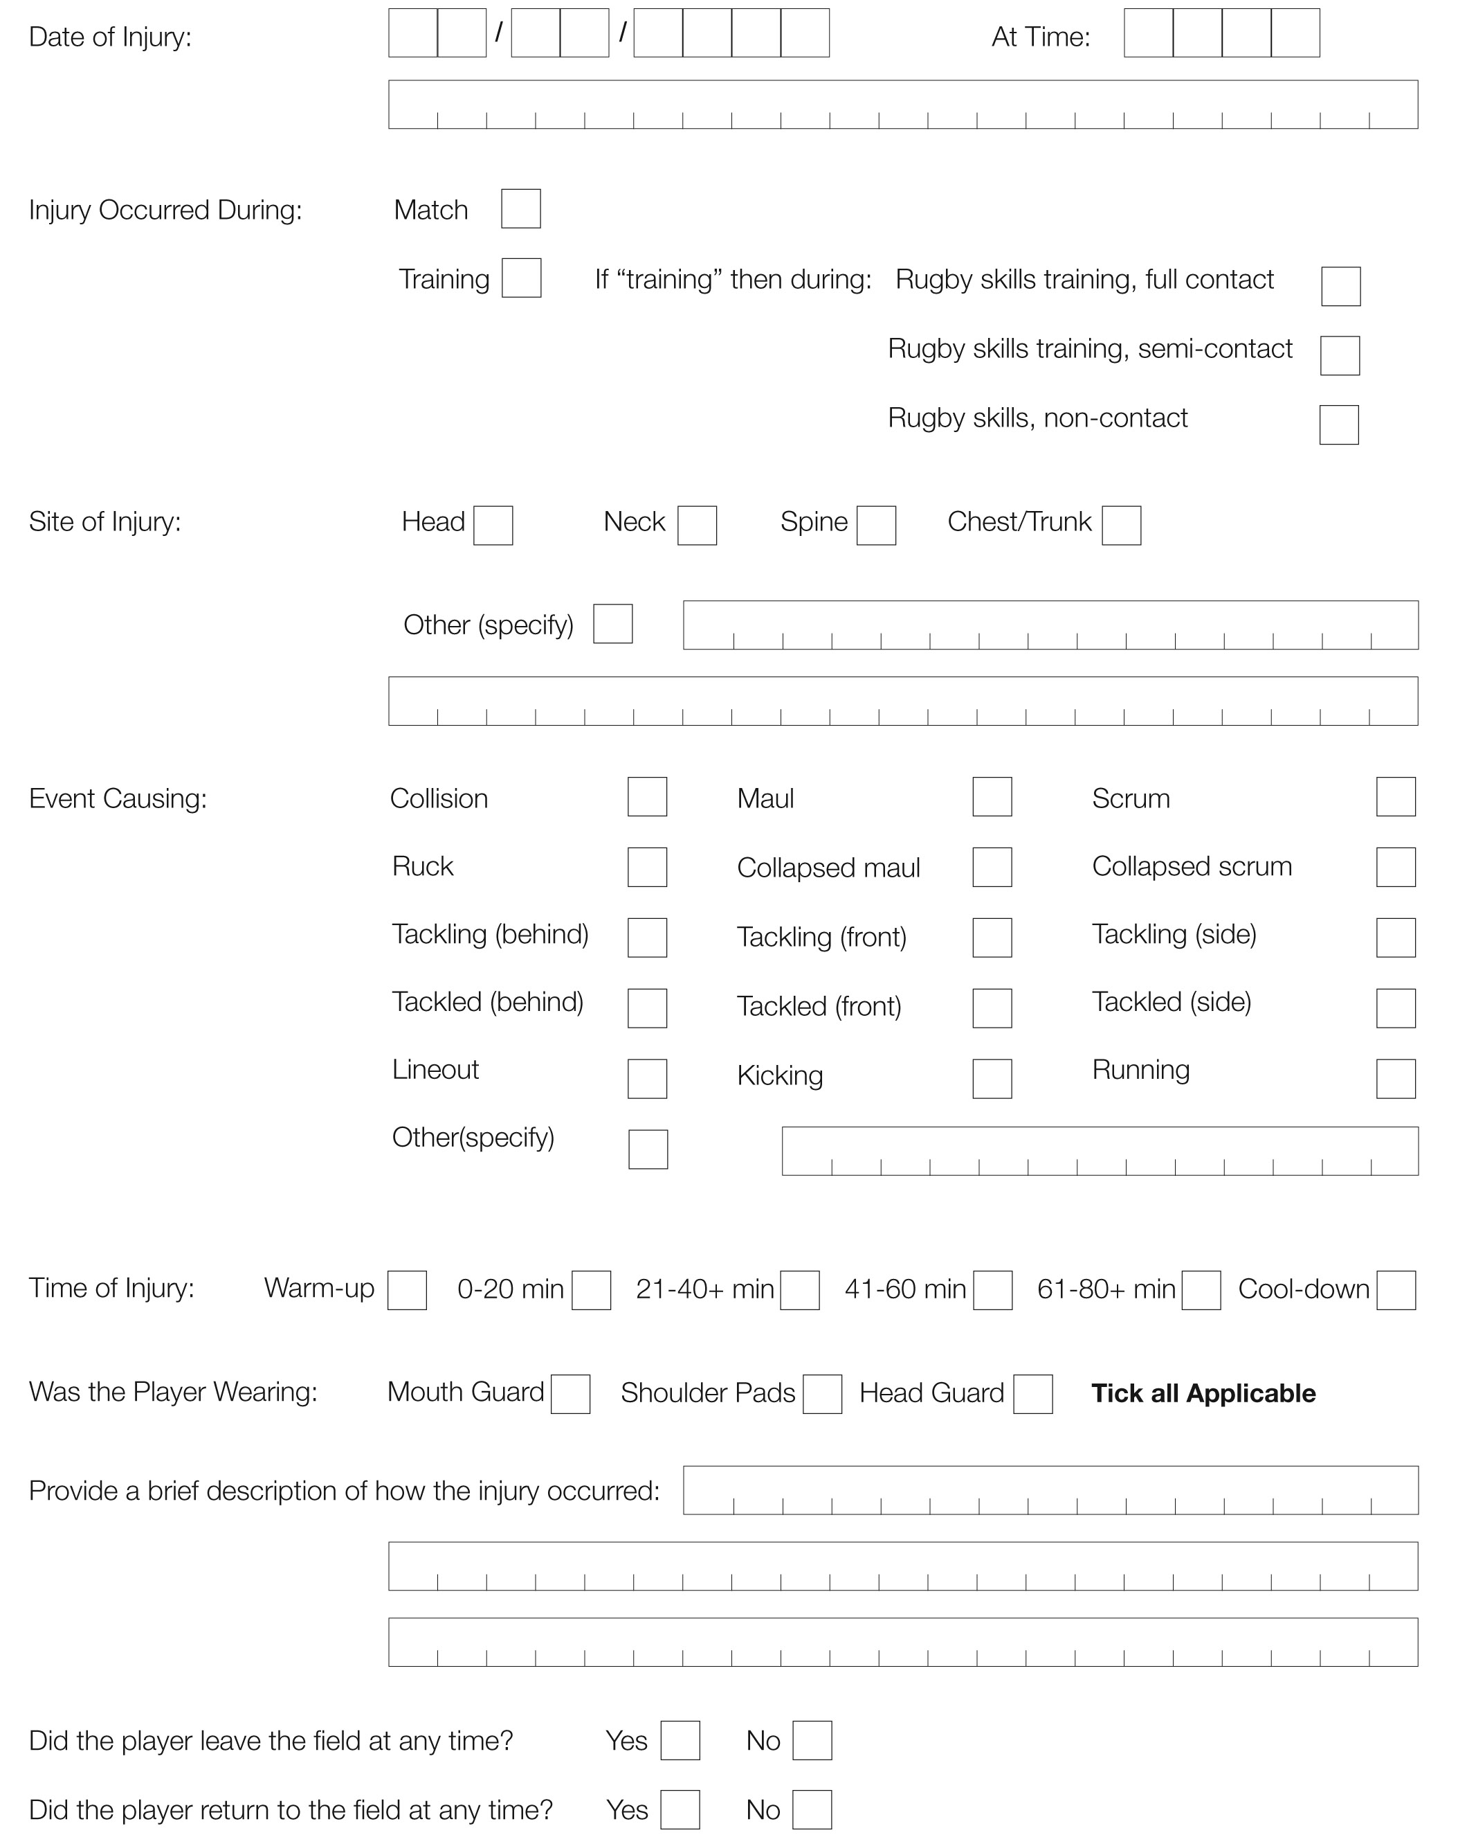
2. injury (Print Clearly)

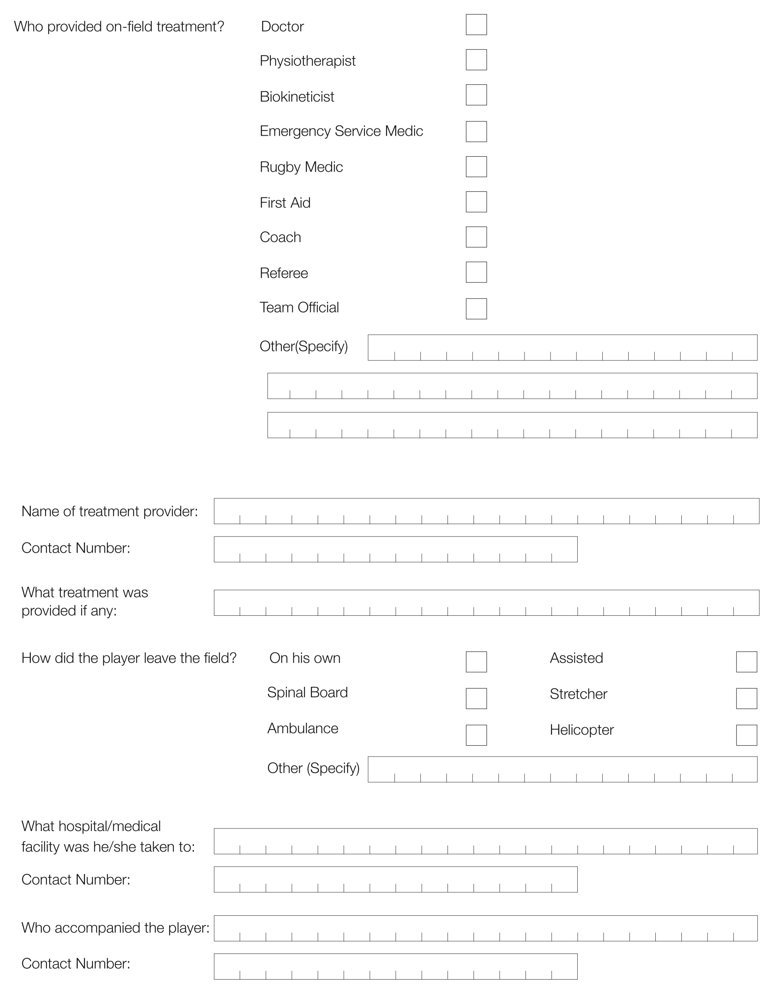
2. injury (Print Clearly) - Continued

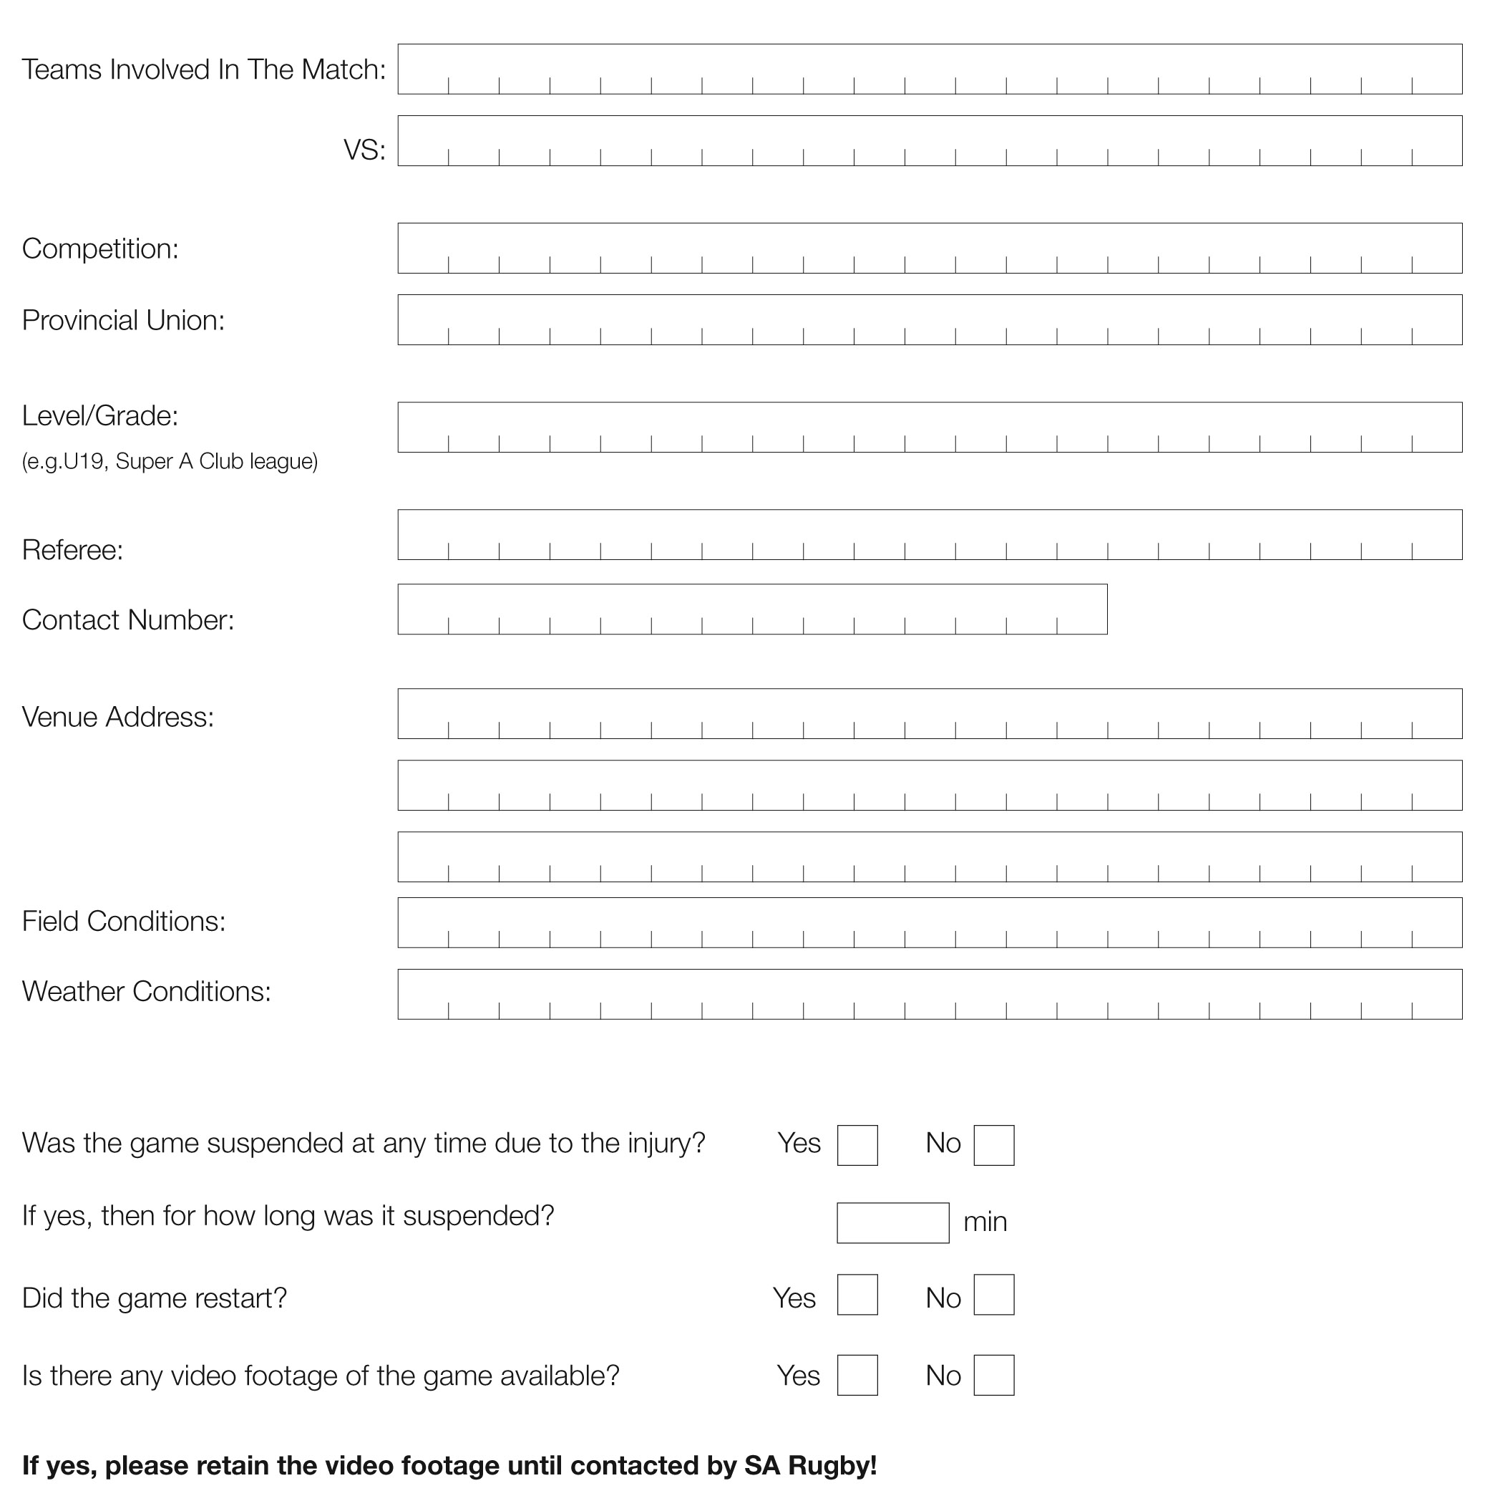
3. match (Print Clearly)

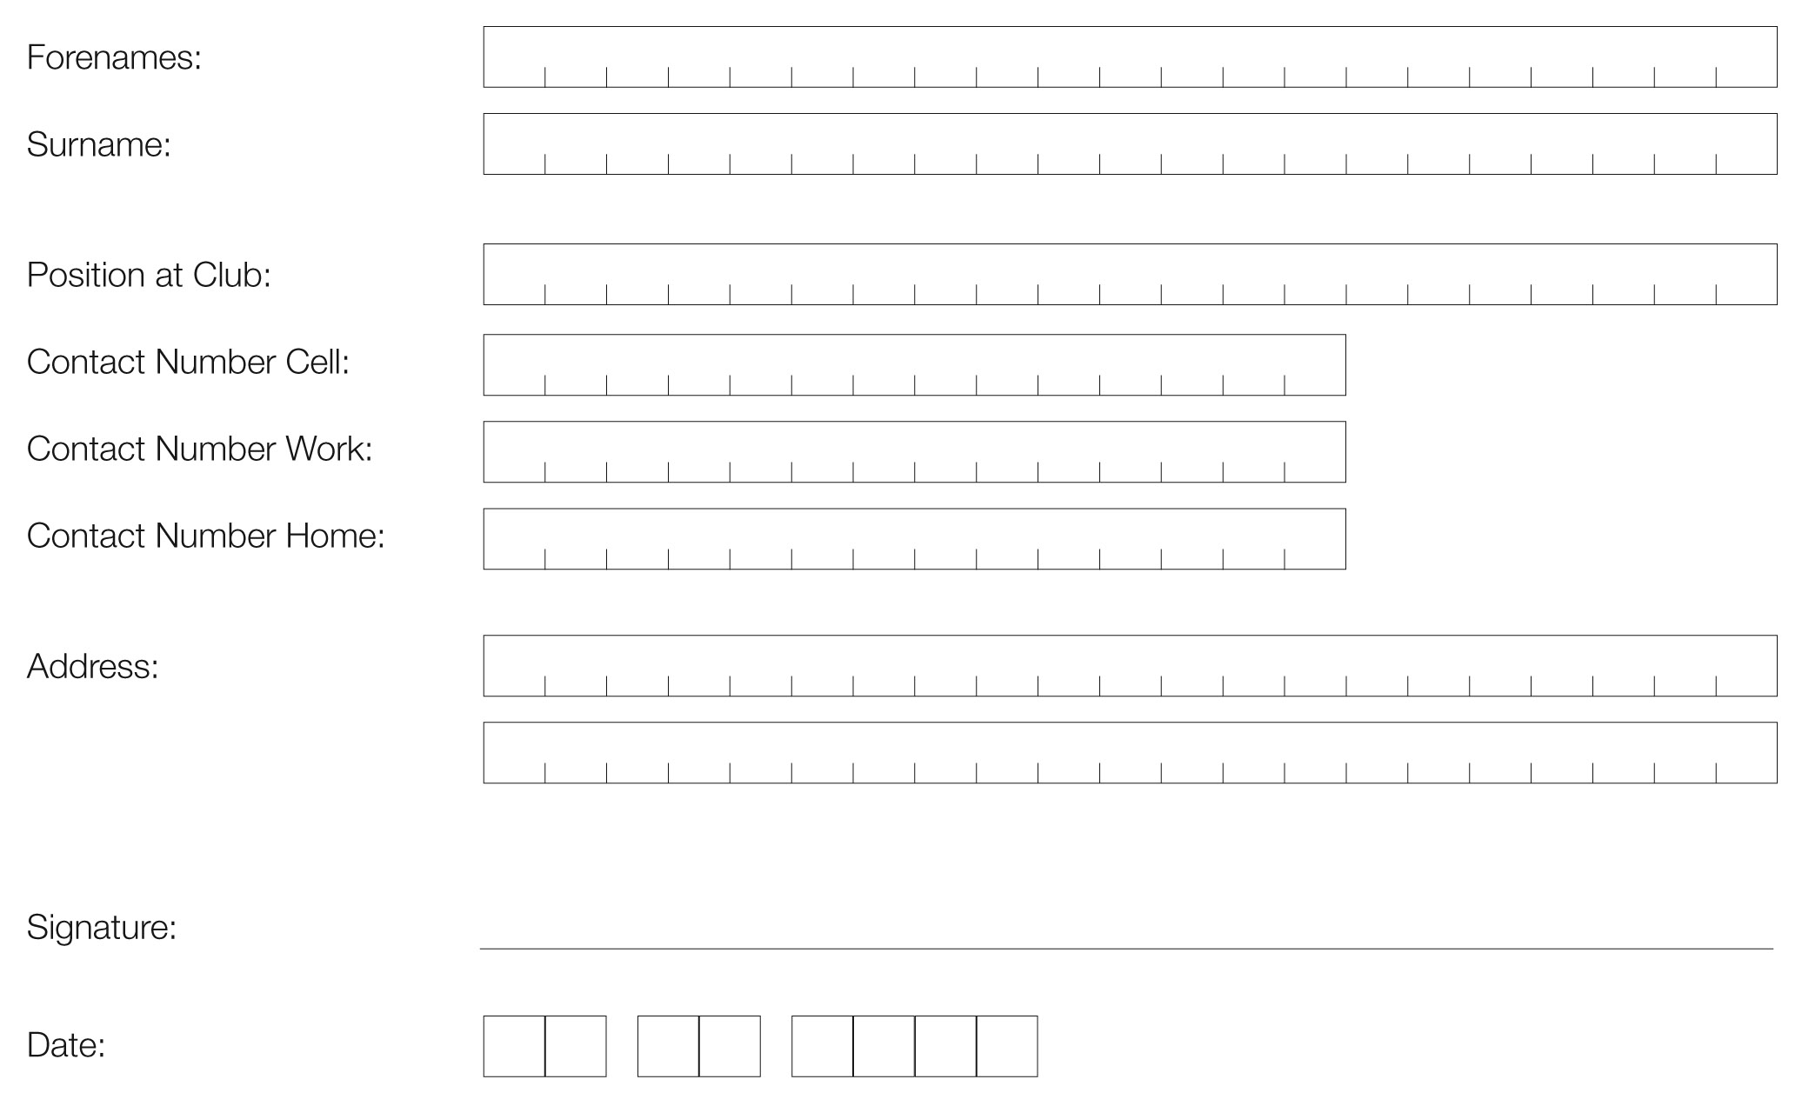
4. club contact (Print Clearly)

5. PROVINCIAL UNION Boksmart Coordinator
CONTACT DETAILS:

Boland: Linston Manuels | 0822293301 | 021 8732317 | linston@bolandrugby.com
Border: Sindile Mayende | 0742295990 | TBC | sindilemayende@gmail.com
Blue Bulls: Johan Vermeulen | 0835845826 | 012 4200743 | johanv@bluebull.co.za
Angelique Jacobs | 012 420 0700 | AngeliqueJ@BlueBull.co.za
SWD Eagles: Martin de Vos | 0734442551 | 044 8730137 | martin@swdeagles.co.za
Eastern Province: Mazwi Dingana | 0670994112 | 041 4088922 | mazwi.epru@gmail.com
Richard Jordaan | 0825945380 | 041 408 5108 | richard@eprugby.co.za
Free State: Selvyn Colby | 0845834487 | 051 4071749 | scolby@fsrugby.co.za
Griquas: Kat Swanepoel | 0828223770 | 053 8328773 | Refs@gwrugby.co.za
Griffons: Steps (Stefan) Pretorius | 0728310998 | 057 3526482 | steps@griffonsnfs.co.za
Leopards: Henry Stewart | 0845876369 | 018 2975304 | stewart@leopardsrugby.co.za
Limpopo Blue Bulls: Sakkie Vermeulen | 0832857782 | 015 2914752 | sakkie@bluebull.co.za
Lions: Timmy Goodwin | 0828508707 | 011 4022960 | timmy@glru.co.za
Pumas: Ade Adendorff | 0844014739 | 013 612 0534 | ade@pumas.co.za
Sharks: Archie Moko | 0844317562 | 031 3088426 | archie@kzn-rugbyunion.co.za
Valke: Alfred Ross | 0824573278 | 016 9762112 | aross@icon.co.za
Western Province: Samuel Mahlatsi | 0798843600 | 021 6594502 | smahlatsi@wprugby.co.za

